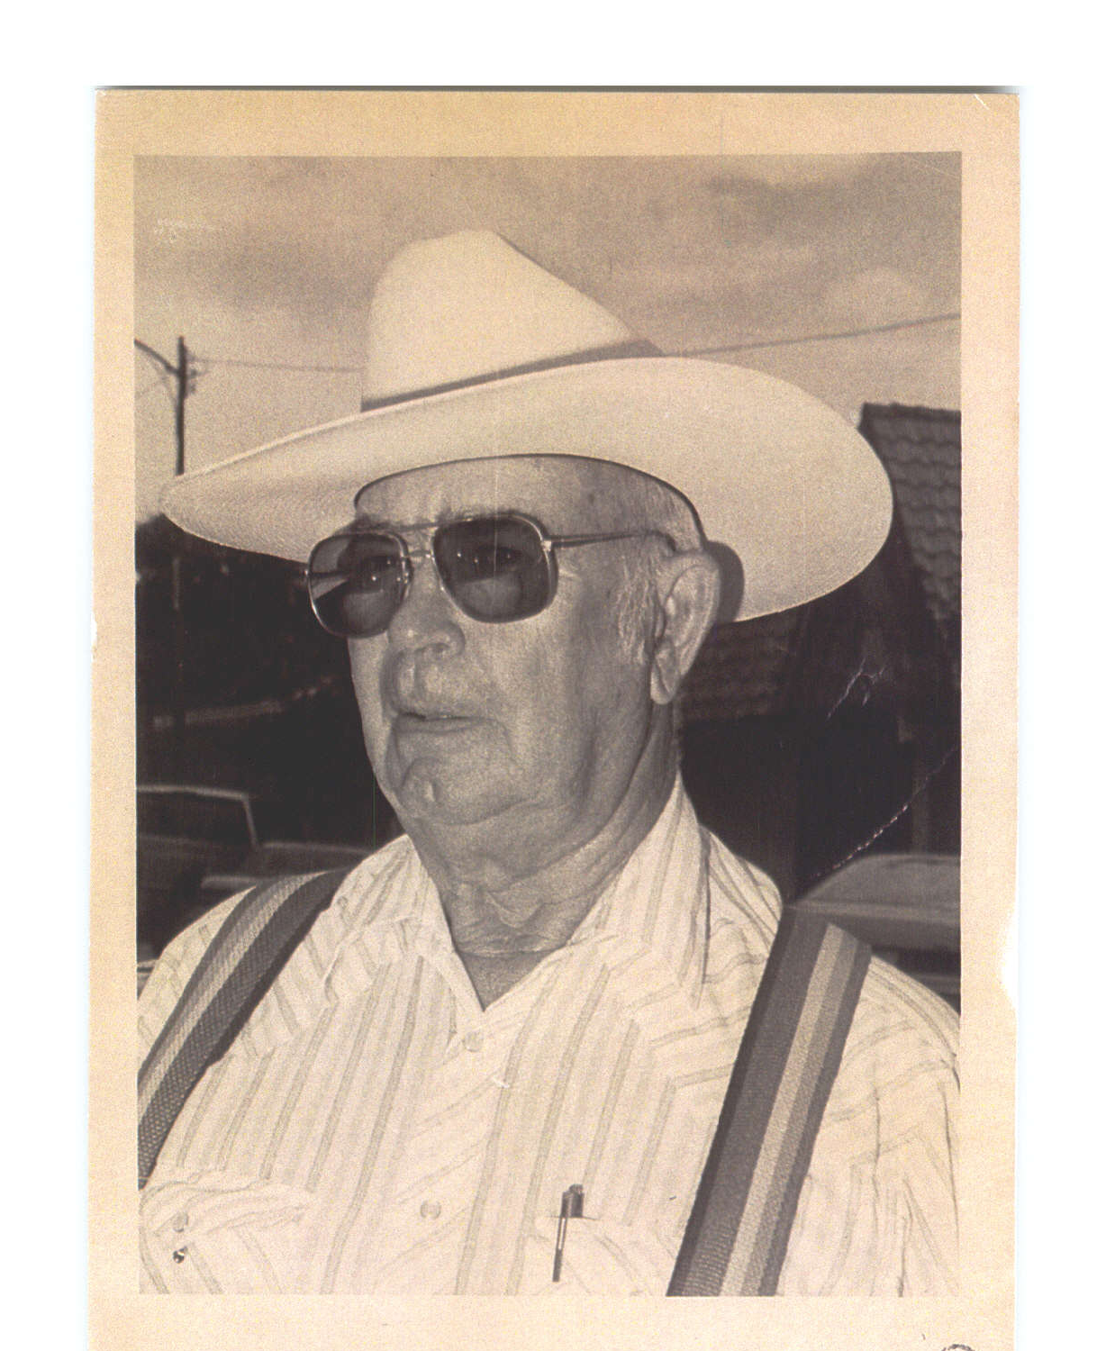
Return to your counselor (name of counselor):
______________________________________________
No Later than March 15, 2024!

Application for the
Ray Ira Prather Scholarship

For the 2023-2024 year

(Please Type or Print.)
Full and complete information appreciated as information from below will be used for publication if scholarship is rewarded.

- Name:_____________________________________________________________________

- Permanent Address:__________________________________________________________

- Phone #:___________________________________________________________________

- Date of expected graduation from high school:_____________________________________

- High school attending:________________________________________________________

- Parent(s) or guardian name(s):__________________________________________________

- College you plan to attend:________________________Location:_____________________

- Area of study planned:________________________________________________________

- Using space provided, list major activities, honors and offices held in school and in the community over the last four years:

(Over)

- Please attach letters of recommendation from three individuals (non-relative) who are familiar with your character.

- Have you been made aware of any other grant or scholarship awarded to you? If so, please provide the name and amount.

- Please provide as an attachment your high school transcript which shows your GPA and copies of your SAT or ACT score.

- In the space provided, please give your reasons for attending college and personal goals.

_________________________________________Signed Date

NOTE: Successful applicants must accept the award by written acknowledgement sent to:
Plano Land Trust, PO Box 314, Wray, CO 80758,
before proceeds will be disbursed to the designated institution.

