Ray Ira Prather Scholarship Guidelines

Plano Land Trust Corporation a 501(c)(3) organization for the scholarship award program for the “Ray Ira Prather” estate. The program is to be administered by the Prather Scholarship selection committee; all decisions mandated by the committee are final.

The following criteria are set forth for the application process:

1) Who May Apply:
Students who attend a public high school in Yuma County, Colorado shall have priority over other Colorado residents.
High school seniors who are seeking college and/or trade school admission who have satisfactory scholastic aptitude
scores to gain such admission.
Seniors who have maintained a 3.0 gpa and have (or will) obtained a high school certificate of graduation.
Candidates must be U.S. Citizens.
Applicant can apply to any state certified institution of higher learning available in the United States.

2) How To Apply:
A copy of this guideline is to be provided to each high school guidance counselor located in Yuma County.
School guidance counselors shall make available the guidelines to all prospective candidates without regard to race,
color, creed or religious affiliation.
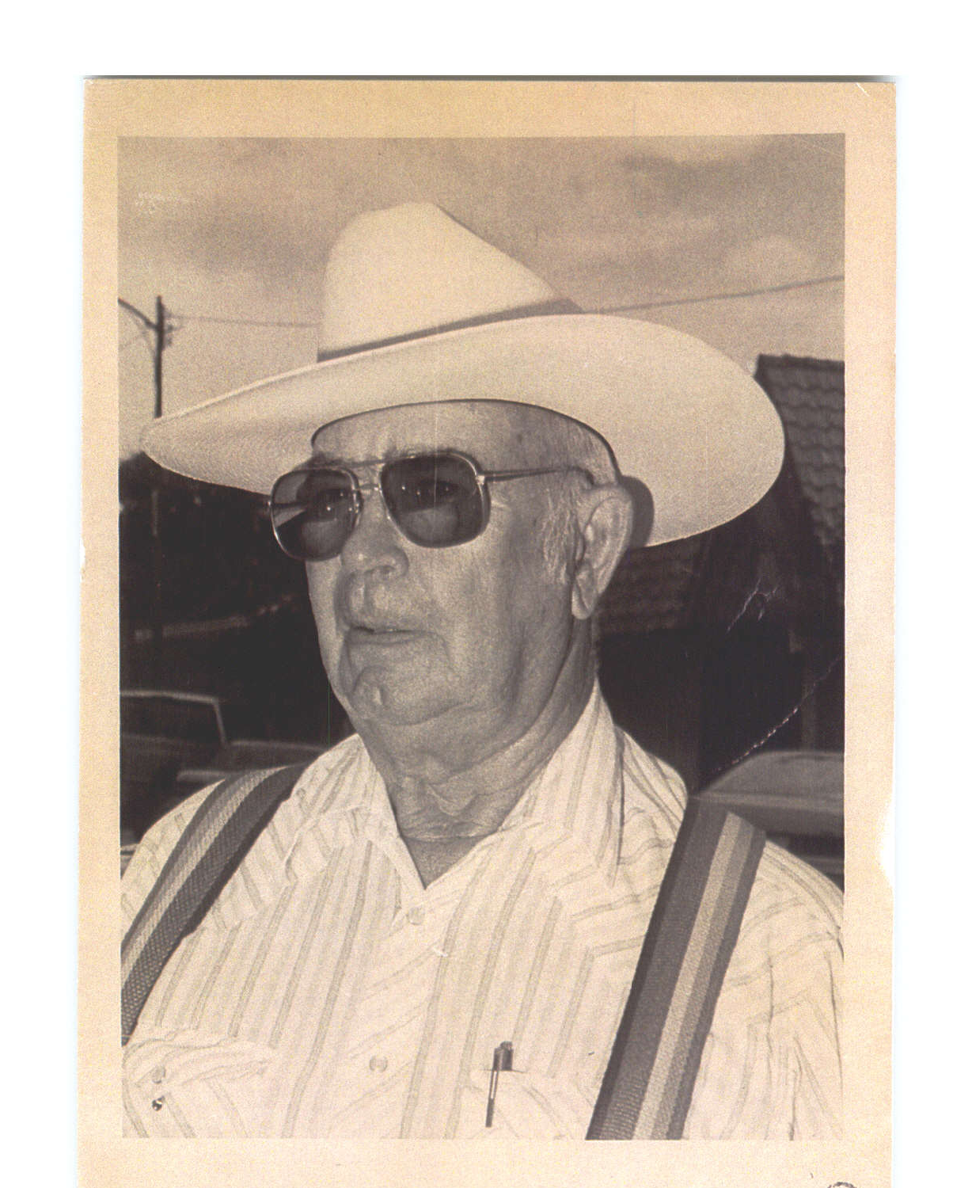
A completed application shall be returned to your guidance counselor office (or designated person) no later than March 1st.
If it is a renewable request, a letter to Plano Land Trust dated no later than April 30th, of each year.

3) Selection criteria Procedure:
A selection committee consisting of the guidance counselor or appointed
representative shall meet to review applicant candidates in April of each year.
The criteria to be judged shall be:
    - Prior academic performance.
    - Recommendations from instructors, principals and community member.
    - Leadership evidence in the community.
    - Demonstration of motivation, character, ability and potential.
• After evaluation of the candidates the selection committee shall make their
recommendations to the appointed representative of the Ray Ira Prather
Scholarship fund as soon as practical thereafter.

4) Terms & Conditions of Scholarship:
• Scholarships shall be awarded in the name of Ray Ira Prather.
• The award shall be up to $2,000.00 per each successful first year candidate payable by check to the institution where applicant shall attend.
• Before payment shall be made the applicant shall be required to accept the award by acknowledgment to the committee or designated representative.
• If the award is not accepted or the check is uncashed after 180 days, the funds will be re added to the Prather account and the check shall be declared null & void.
• Renewability of scholarship. A successful candidate may renew his/her scholarship for up to 3 years of consecutive secondary education by reapplying to the designated agent in writing to:
Plano Land Trust Scholarship Award, PO Box 314, Wray, CO 80758
• Successive renewal awards will be granted as long as candidate supplies proof of continued 3.0 grade performance from the prior semester and acceptance by the school for the upcoming term.
• At the discretion of the Prather Scholarship committee, the funds available of up to 50% of total scholarship funds shall be split among the renewal applicants received by March 31st of each year. You must submit your request in writing by March 31st..

